Internship Reflection
Christopher Gonzalez
Pavilion
September 2026
At the beginning of the internship, I found myself caught between two contrasting emotions: confidence and nervousness, both competing for control. From the moment I began my internship interview with Jim which by the way I genuinely consider him one of the greatest people I have ever had the privilege of meeting, and I say that wholeheartedly. He reminds me deeply of my father: intelligent, goal-oriented, driven, and an exceptional leader who knows how to inspire and motivate those around him. Yet, beyond all those qualities, what stands out most to me is his kindness and compassion. He possesses the strength of a lion while maintaining a genuinely warm and generous heart. That combination of leadership, determination, humility, and kindness is what makes him someone I hold in such high regard.
I remember that interview like a flashback of my childhood memory getting my first toy I really wanted. My skills were brought to the table, from SQL to coding languages to machine learning. Then, it happened I was introduced to the team where I met one person in particular whom became my mentor through my journey, when I say I learned it all from him I mean it from book studying QA protocols, teaching me the process and expectations, understanding the hardware, smoke testing, test casing, introduction to azure, etc. I mean it all. Donavon introduced me to their pride if you would. That’s when I knew I had to transaction to a lion position. Another person who I cherish wholesomely as he learned a lot from older developers and managers, his good skills, communication standards, profluent understanding show it. One of many who I am thankful to heart to have met. Many familiar faces that lifted my journey Kristein, Bankie, Erick, Mark, Nick, Shannon, Brian, Tina. Theres too much to write down.
Throughout the internship, I was focused on learning the team’s tools, processes, and expectations. As I became more familiar with the environment, I took on responsibilities involving testing, bug identification, documentation, and automation. Throughout the internship, I worked on creating test cases, validating functionality, documenting issues, and supporting efforts to improve efficiency through automation. One of the most rewarding parts of the experience was seeing how each phase of the software development lifecycle connects together to deliver quality solutions. This internship helped me become more confident in my technical abilities, strengthened my problem-solving skills, and gave me valuable experience working in a professional environment. I also learned the importance of communication, collaboration, and attention to detail when working on technical projects.
[The first phase week 1 – 4]
Things I learned throughout the phases. The first phase week 1 – 4 I learned, QA fundamentals and terminology, defect lifecycle process, QA workflows and policies, azure DevOps processes, QA metrics and release readiness. This documentation is online. It shows the procedures for work.
[projects] – Link, CashIo, Tap2Play, VIP Connect. (these projects are hardware machines that request and post API’s) actions just as deposit, withdraw, dispense, Cash drop, coin drop, tap to play, register a user.

Contents
[Phase 1 Skill Development] 6
[Bug communication] 7
Figure 1. Azure DevOps Defect Documentation. One of my first QA responsibilities was documenting defects in Azure DevOps. This defect involved inconsistent error handling when a cash dispenser was disconnected. I documented the issue, created reproducible steps, recorded the actual behavior, and followed the QA defect lifecycle until the issue was fixed and verified. 7
[test case creation] 8
Figure 2. Azure DevOps Test Case Creation. I created a detailed test case in Azure DevOps to validate the conversion of a VIP Manual account to a VIP Online account. This exercise taught me how to translate business requirements into structured test steps and expected outcomes that can be executed consistently across testing cycles. 8
[Azure DevOps work tracking] 9
Figure 5. Azure DevOps Work Tracking. Example of the Azure DevOps workspace used to manage QA work items, test cases, bugs, user stories, and workflow statuses throughout the software development lifecycle. 9
[Bug triage participation] 10
Figure 6. Azure DevOps Test Case Creation. I created a detailed test case in Azure DevOps to validate the conversion of a VIP Manual account to a VIP Online account. This exercise taught me how to translate business requirements into structured test steps and expected outcomes that can be executed consistently across testing cycles. 10
[Tap2Play Go-Live observation] 11
[VIP Connect exploratory testing] 12
Figure 7. Azure DevOps Test Case Creation. Conducted exploratory and regression testing within VIP Connect, validating critical user workflows including enrollment, bank linking, account management, and transaction-related functionality. This experience strengthened my ability to investigate application behavior, execute test scenarios, and identify potential defects. 12
[Phase 2 Skill Development] 13
[VIP Connect Regression Testing] 14
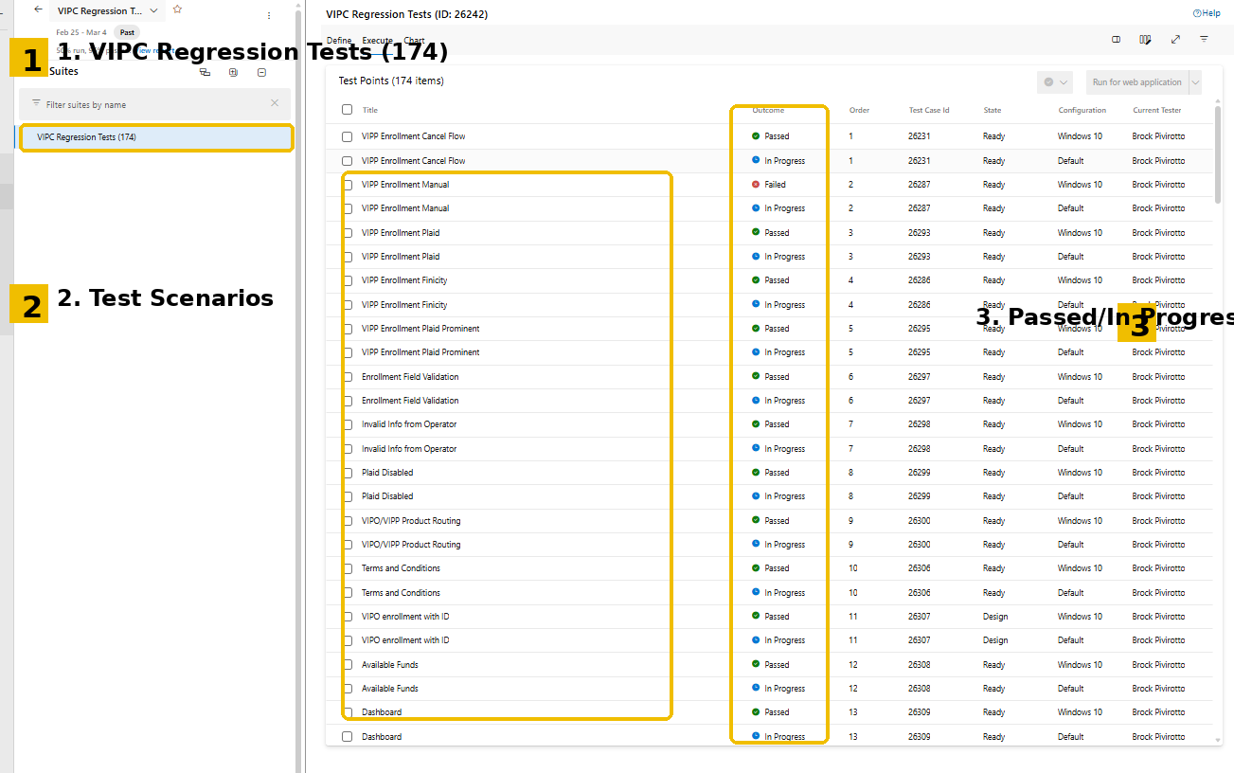Figure 8. Executed VIP Connect regression test suites to validate critical customer workflows and maintain product quality across releases. 14
[Automation Test Case Creation] 15
[Phase 3 API Testing & JSON Validation] 16
[Positive & Negative Test Scenarios] 17

[Phase 1 Skill Development]

[Bug communication]
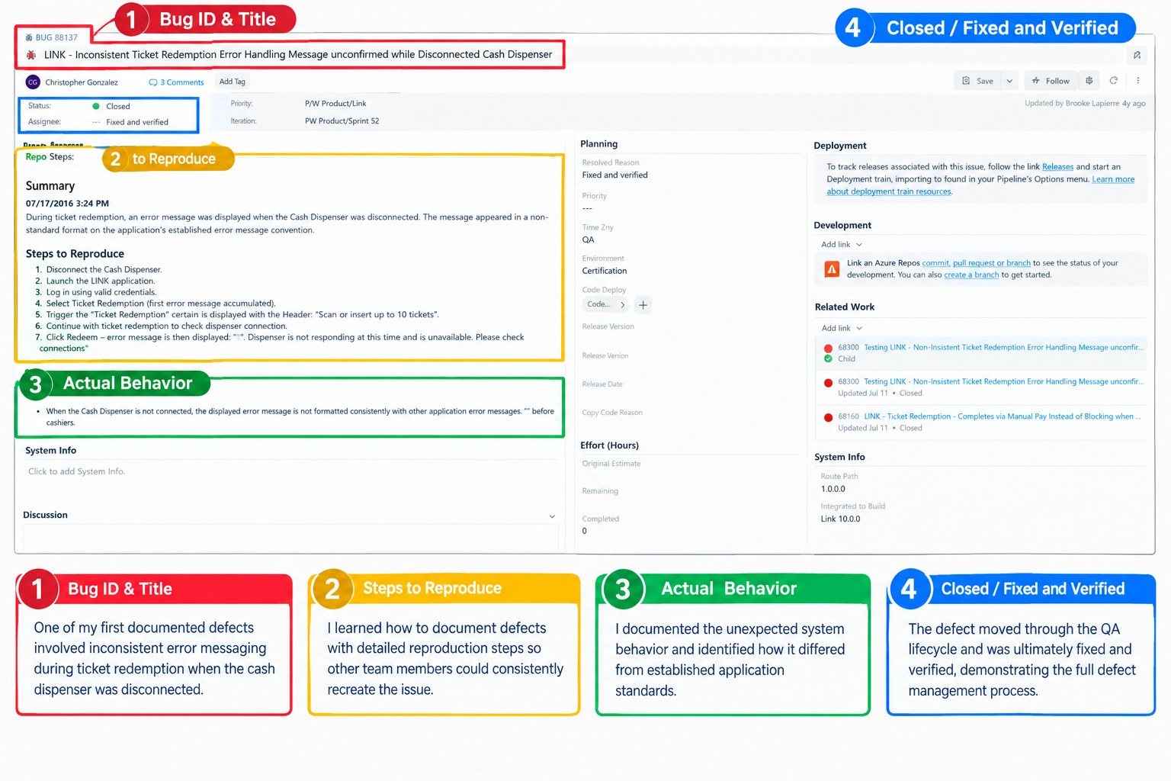

Figure 1. Azure DevOps Defect Documentation. One of my first QA responsibilities was documenting defects in Azure DevOps. This defect involved inconsistent error handling when a cash dispenser was disconnected. I documented the issue, created reproducible steps, recorded the actual behavior, and followed the QA defect lifecycle until the issue was fixed and verified.

[test case creation]
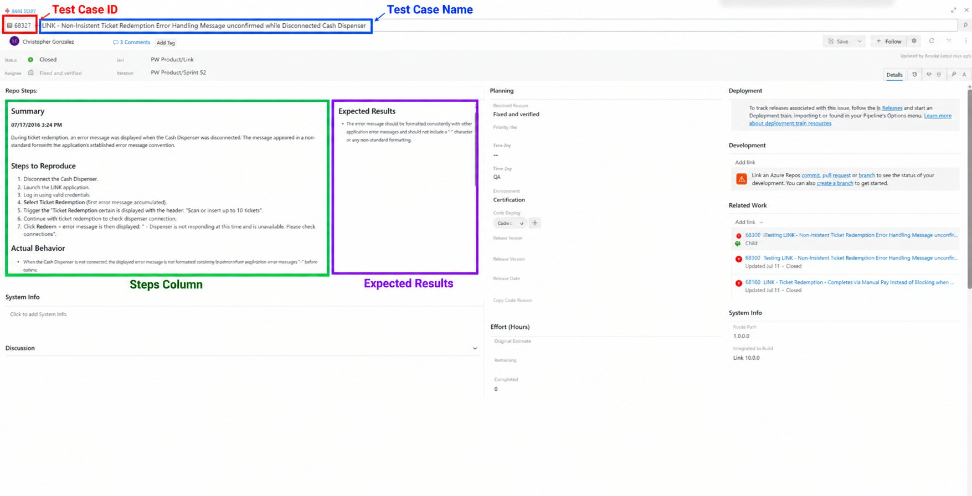

Figure 2. Azure DevOps Test Case Creation. I created a detailed test case in Azure DevOps to validate the conversion of a VIP Manual account to a VIP Online account. This exercise taught me how to translate business requirements into structured test steps and expected outcomes that can be executed consistently across testing cycles.

[Azure DevOps work tracking]
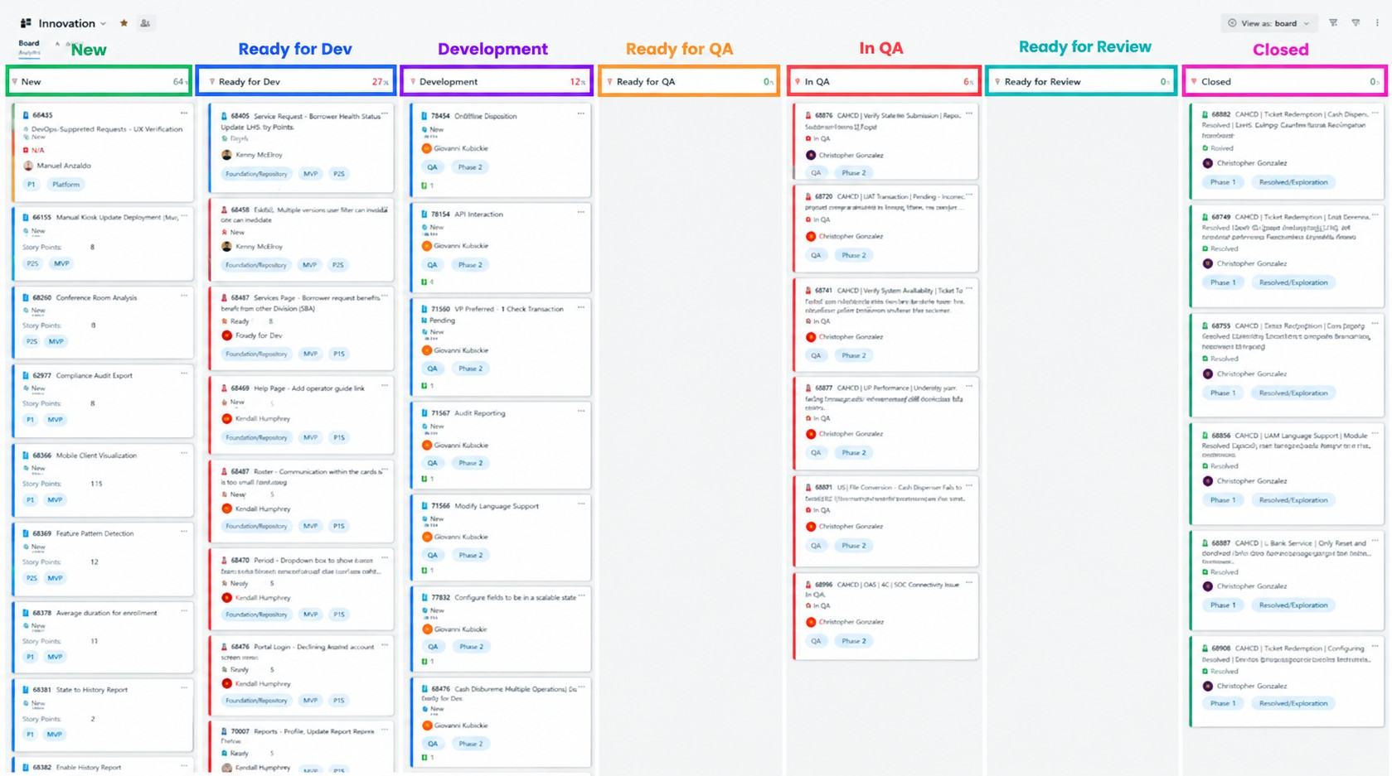

Figure 5. Azure DevOps Work Tracking. Example of the Azure DevOps workspace used to manage QA work items, test cases, bugs, user stories, and workflow statuses throughout the software development lifecycle.

[Bug triage participation]
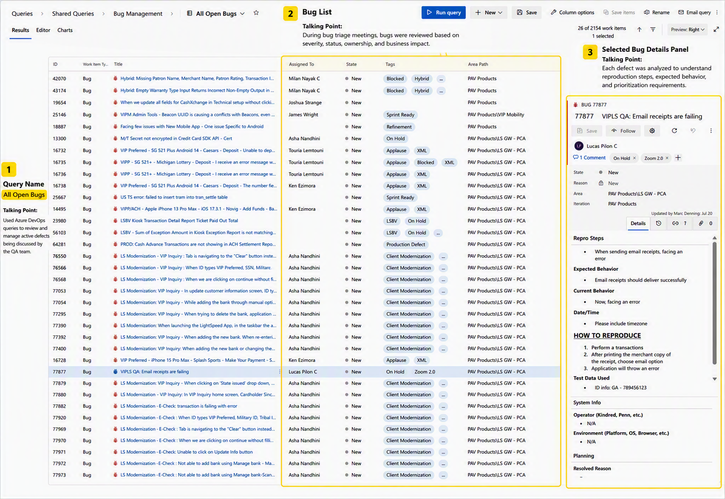

Figure 6. Azure DevOps Test Case Creation. I created a detailed test case in Azure DevOps to validate the conversion of a VIP Manual account to a VIP Online account. This exercise taught me how to translate business requirements into structured test steps and expected outcomes that can be executed consistently across testing cycles.

[Tap2Play Go-Live observation]
There is no photo to show the actual live environment. This project consisted of tapping a mobile apple device with Bluetooth and communicating with a device integrated that allows the user to add funds to their slot machines without having to go through the withdraw and deposit flow. A convivence for a patron and a feature for the slot machines.

[VIP Connect exploratory testing]
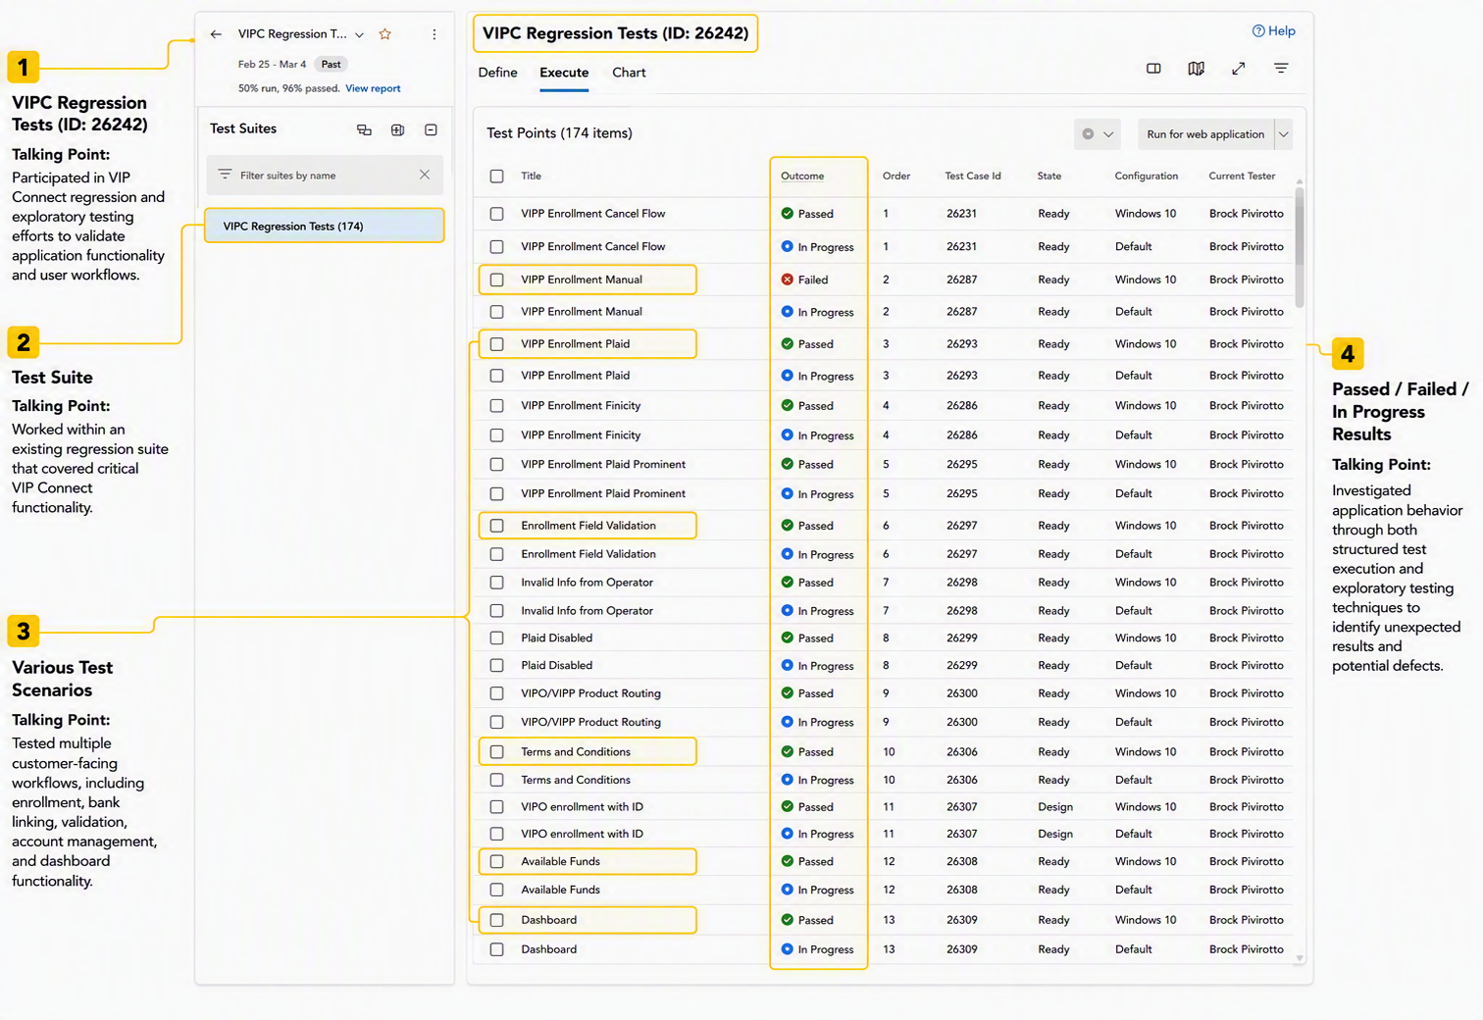

Figure 7. Azure DevOps Test Case Creation. Conducted exploratory and regression testing within VIP Connect, validating critical user workflows including enrollment, bank linking, account management, and transaction-related functionality. This experience strengthened my ability to investigate application behavior, execute test scenarios, and identify potential defects.

[Phase 2 Skill Development]
During Phase 2, I transitioned from learning QA concepts to actively contributing to testing and automation efforts. I applied my knowledge through regression testing, API validation, automation development, and performance testing while working more independently under the guidance of QA engineers.
Key Skills Developed
- Regression Testing
- API Testing
- Automation Development
- JSON Analysis
- Performance Testing
- Problem Solving

[VIP Connect Regression Testing]
Executed regression test suites to validate existing VIP Connect functionality and ensure new changes did not impact previously working features.

Figure 8. Executed VIP Connect regression test suites to validate critical customer workflows and maintain product quality across releases.

[Automation Test Case Creation]
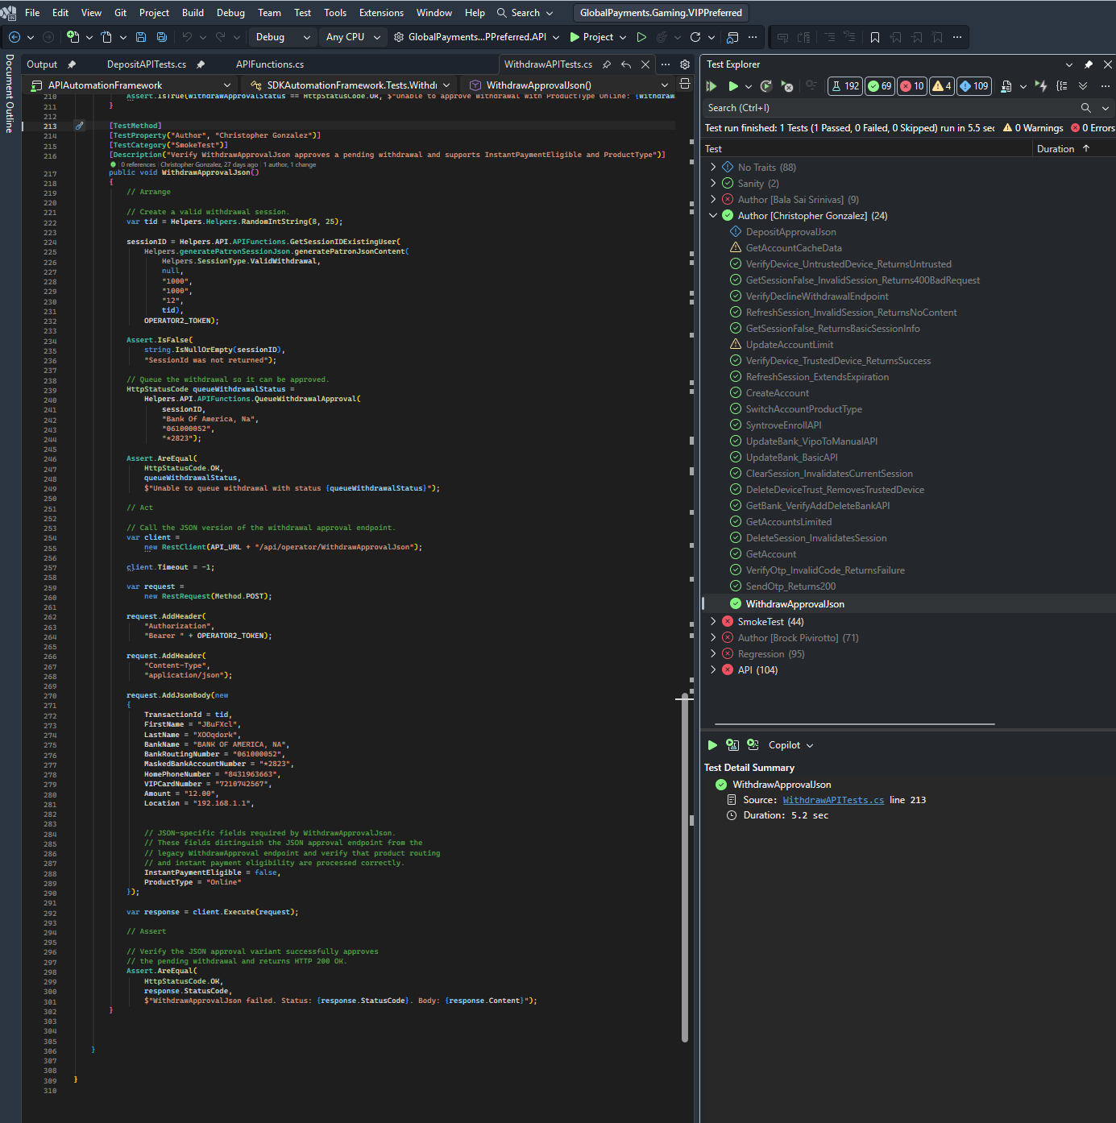 Picture 9.Creation of an Api automation.
This end point of API is calling :
POST /api/operator/WithdrawApprovalJson — add to WithdrawAPITests.cs

[Phase 3 API Testing & JSON Validation]
Picture
- Postman Collection
- API request/response examples
- JSON payloads
Highlight
- Request URL
- Response body
- Success/failure validation
I learned API testing fundamentals by validating requests and responses, analyzing JSON data, and ensuring backend functionality behaved as expected.

[Positive & Negative Test Scenarios]

